Ideation Phase
Brainstorm & Idea Prioritization Template

Date | 2 November 2025
Team ID | NM2025TMID02717
Project Name | Optimizing User, Group, and Role  Management with Access Control and Workflows
Maximum Marks | 4 Marks

Brainstorm & Idea Prioritization Template:
Our idea is to implement a role-based access control system with automated workflows for user, group, and role management in a project management environment.The core problem is that the current system lacks clear role definitions, structured access permissions, and automated task workflows. This causes confusion in task assignments, accountability, and security, especially in small teams like the one consisting of Alice (Project Manager) and Bob (Team Member).Using ServiceNow, we plan to define roles clearly (e.g., Project Manager, Team Member), associate users with their roles and groups, and implement access controls to ensure only authorized users can view or modify specific tasks. Additionally, workflows will automate task assignments, status updates, and notifications to improve project tracking and accountability.This solution is expected to have a high impact by improving team clarity, reducing errors in access permissions, and boosting overall productivity and security.
The feasibility is high, as ServiceNow provides built-in capabilities for role management, access control (ACLs), and workflow automation that can be configured with minimal coding.Based on impact and feasibility, we prioritize this idea as high, with an overall score of 9 out of 10..

Step-1: Team Gathering, Collaboration and Select the Problem Statement
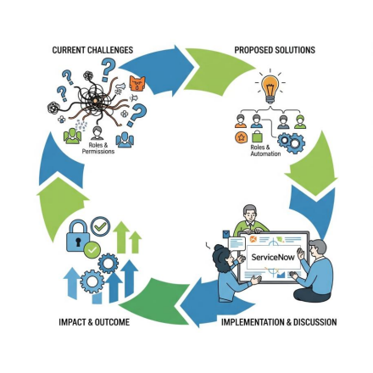

Step-2: Brainstorm, Idea Listing and Grouping

? Brainstorming

● Improve team accountability using automated task status tracking.
● Define precise access levels for different roles in the project.
● Use dashboards for real-time project visibility.
● Introduce approval workflows for task completion.
Idea Listing

1. Role-based access controls (RBAC)
2. Custom workflows for project tasks
3. Project-specific user groups
4. Automated notifications and escalations
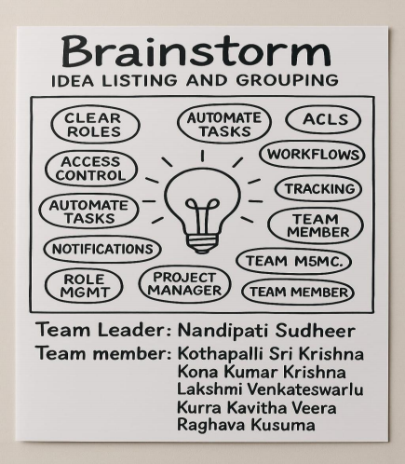

Step-3: Idea Prioritization

High Priority - High Impact, Easy Implementation

● Implement role-based access control (RBAC)
● Setup project-specific user groups for permission clarity

High Priority - High Impact, Hard Implementation

● Design and automate task lifecycle workflows
● Introduce approval steps for task closure

Low Priority - Low Impact, Easy Implementation

● Add automated email notifications on task updates
Low Priority - Low Impact, Hard Implementation

● Build complex escalation flows and advanced dashboards
